Little SPARK: Simple Play Adaptations to Reference for Kids

Jiobit Gen 3 - GPS Tracker for Kids
Description: | Image:
Jiobit is 1.96 x 1.45 x 0.47 inches and weighs 0.8 ounces. It easily and discreetly attaches to clothing, shoes, backpacks, etc. The Jiobit is paired with a caregiver's smartphone to deliver real-time location information that will track in any location at any distance, and includes Alert Notification, Location History, Geo-Fence, Real Time Tracking, and SOS with unlimited nationwide range.  Purchasing Information | 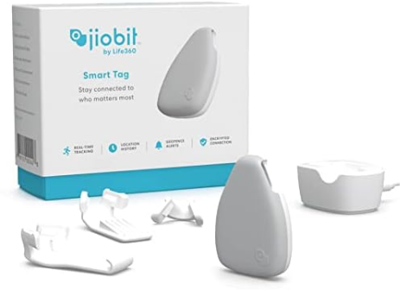

Who Might Benefit?
Those who supervise children who wander, act on impulse and try to leave the area, or follow other children.
Why Use?
Provides an opportunity to act as a safety measure for those who try to leave due to overstimulation, feeling upset or frightened, wandering from supervised areas, or attention seeking.
Instructions for Use: | Adaptation Ideas:
Environmental Considerations  - Create boundaries such as a taped box in front of the doorway as a “no stand zone”.  - Place a stop sign on door or outside gate.  Positioning  - Strategically place the child away from an accessible door.  Basic Play/Use  - Attach to any item that remains with the individual.  - Subscription data plan is required to connect.  Play/Use with Others  - Create and place a poster about leaving the area to be reviewed daily in morning circle/meeting.  - Combine poster or social stories about leaving designated areas with community signs/traffic lights with concepts of stop, go, and wait/caution.  - Play Red Light Green Light game and discuss instances of when it is important to stop, and OK to go. | Communication Support  Visuals displaying options of things children can say or do when they feel like they need to "get away".  - Create lanyards for all staff with visuals including stop, wait, I need a break.  - Create an individual or class Social Story (e.g. Staying With My Class, Running Away, I Can Choose to Be Safe).  DIY Alternatives  - “Sleigh bells” or other movement triggered noisemaker on doors and gates.  - Stop signs posted on doors and gates.
Words to Encourage Play/Use
Stop  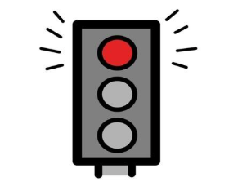 | Go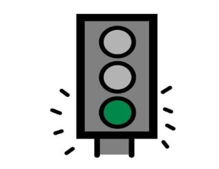 | Wait  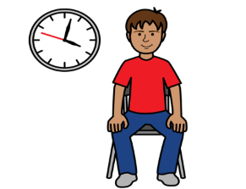
Open 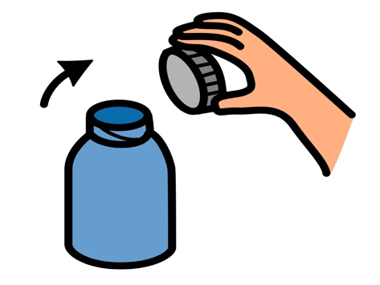 | Close 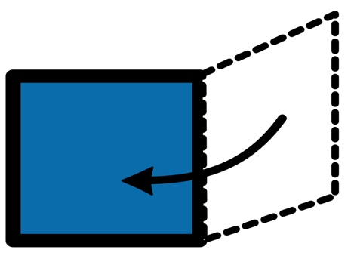 | Help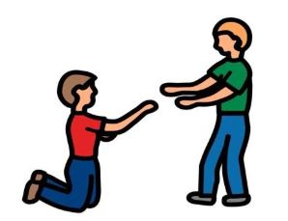
Sad 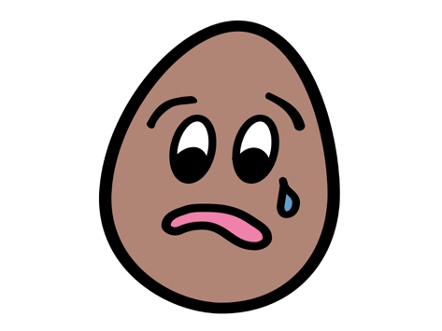 | Mad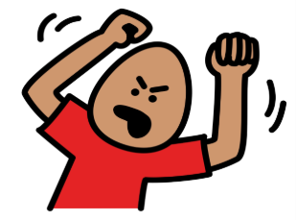 | Scared  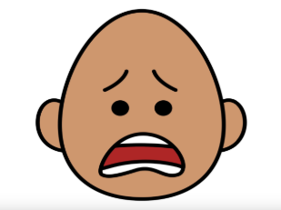
*”Adaptations” adapted from: Haugen’s Modes for Adapting Toys based on materials from the "Let's Play" Project at the University of Buffalo
PCS is a trademark of Tobii Dynavox, LLC. All rights reserved. Used with permission.

